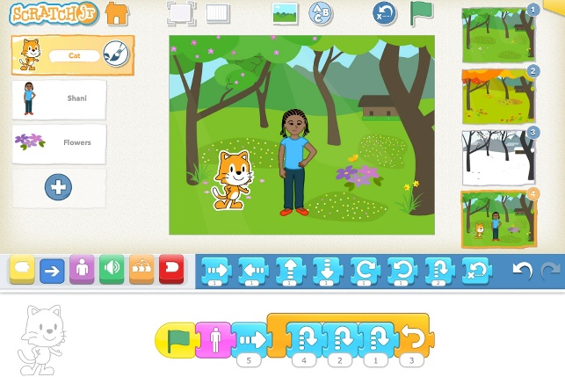
Dear Parents,
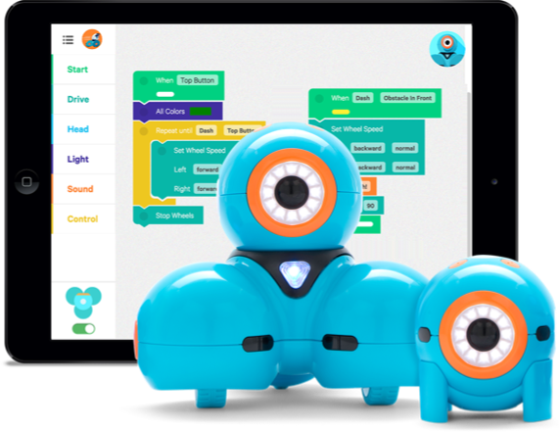
We are very excited to begin implementing a new STEM program here at Tabb Elementary starting in January! Students will be learning to code, to explore robotics, to play with circuits, and have opportunities to build and create. We are in need of some basic “non-tech” supplies – including any kind of Legos, K’nex, or other building materials – to include as part of our rotations. If you are able to donate any of these kinds of building materials, it would be greatly appreciated!!! Just have your child bring them in!

Thanks so much for your assistance and generosity!
Heather Long
(Educational Technology Facilitator)

Examples of types of donations needed:
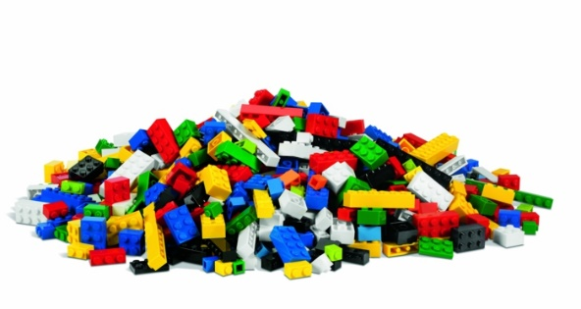  Lego | 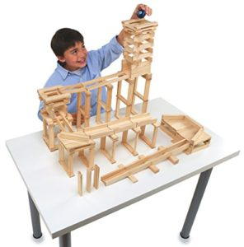  Keva Planks
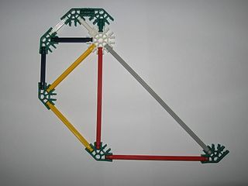  K’Nex | 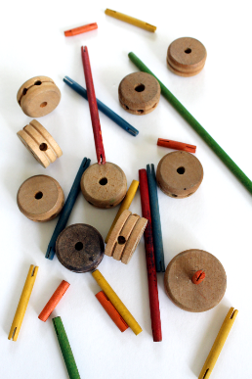  Tinkertoys

