Mind the Maker Rules!
Rule  1 | Be safe!  Walk.  Use materials correctly.  Listen when asked.
Rule  2 | Treat materials with care!  Learn how to use the materials first.  Be gentle. | 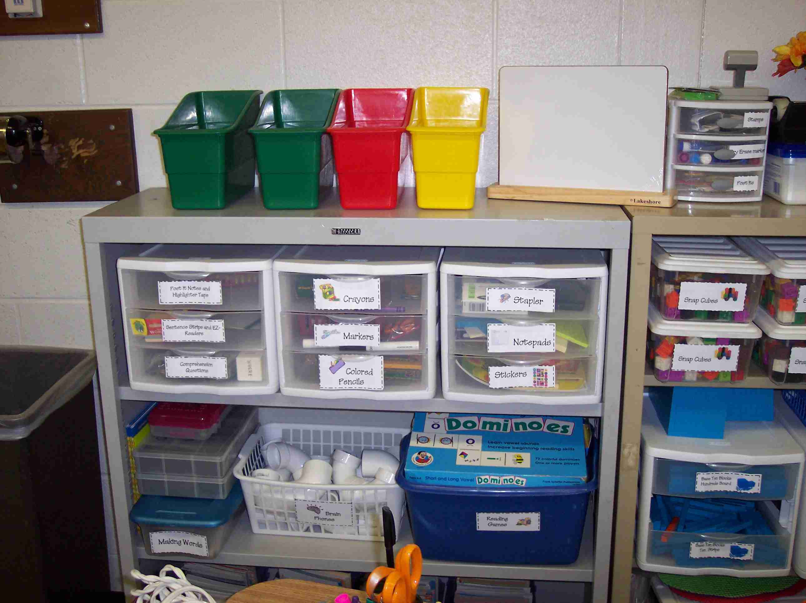
Rule  3 | Share the space!  Share materials kindly.  Take turns when needed.  Bring in materials to trade. | 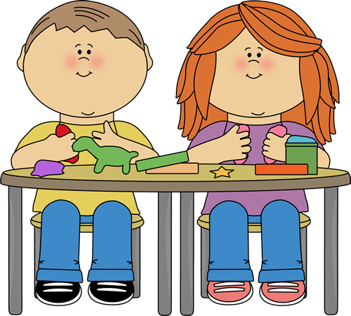
Rule  4 | Clean up!  Put materials away neatly.  Clean the floor.  Store your work carefully. | 