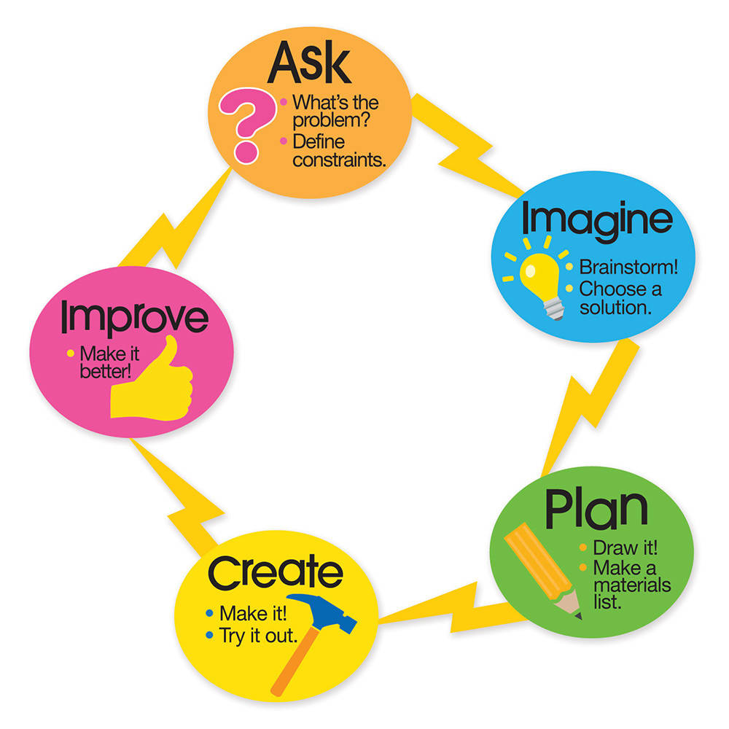STEM project possibilities – endless!

All projects follow the engineering design process:

Anyone:
- Build a story using lego! Then write it. Ex. A multiplication story; a beginning, middle, end challenge (fairy tale, news article, comic) – take photo of the lego creation and put it into one of the programs to tell the story (ex. Comic maker, word, Educreations, iMovie etc.) on ipad.
- December: Design an elf house
- March: Design a leprechaun trap.
- Construct a paper airplane that will fly the furthest.
- Create a Claymation video of some kind of process: plant life cycle, ocean environment, water cycle, food chain, etc.
- Create video tutorials for peers on iPads to explain something.
- Make a weaving using a CD as the base
- Storybook or novel challenges:
  - A new raft for the 3 billy goats gruff
A new bridge for the gingerbread man
A new house for a little pig
A new bedroom for Goldilocks

Grade K:
Sink and float: test aluminum foil boats
Story related: Build a way for the Gingerbread man to get across the river.
Chicks projects: build a chick home; create a documentary of how the eggs hatch
Build an object that includes something from each of the 5 senses.
Create a model of an animal in its home with all that it needs to live.
Create something from recycled materials.
How tall a tower can you build with craft sticks and clothespins?
Tallest lego tower before it falls over?
Tallest solo cup tower?
Keva structure tower?
Create a model of our community buildings on a map.

Grade 1:
Story related: The Three Little Pigs (An Architectural Tale) Build a better house for one of the three little pigs.
Build a lego car with exactly 100 pieces
Build a car that works with wind (blowing on it)
Build the best ramp to get a car the farthest
Create a structure that incorporates motion (circular, back and forth, etc.) – K’nex
Create a musical instrument.
Create a piece of art that includes all the plant parts (sand art, clay, etc.)

Grade 2:
Keva planks: Design an environment for your favorite animal (include water, food, etc.)
Create one of the homes of a Famous American (take a photo and explain using an
iPad).
Create a claymation video of a life cycle of a plant (research first).
Create a model of one of the environments in which the tribes lived, including home, plants, animals. (describe using iPad video, photo, etc.)
Design the best sailboat from limited materials that will sail across a container with a fan.
Design a playground, amusement park
Build a bridge that will support….

Grade 3:
Story related: Mechanimals – rebuild the farm after the tornado that includes at least 4 animals and their pens.
Use Scratch or Scratch Jr. to create an animation that shows a food chain, a natural cycle.
Invent a creature that lives in a volcano (adaptations)
Keva Planks: Design an environment for your favorite animal (include adaptations, food chain).
Create one of the structures from an ancient culture.
Design and test a solution to prevent erosion and weathering
Use lego to model multiplication – photo and explain with iPad app.
Create a Rube Goldberg machine – simple machines!

Rube Tasks: design something that can….
- Hammer A Nail
- Raise and Wave a Flag
- Water a plant
- Shut a door
- Ring a bell
- Break an egg
- Make a ball go into a hole
- Pop a balloon
- Fire a projectile
Grade 4 - 5:
Hatchet: Design a shelter for the main character to survive on the island.
Create a car and test it’s operation on different surfaces to find the one with the least friction.
Use Squishy circuits to build a light up or buzzing creature.
Use little bits to create a vehicle or machine that includes movement or light.
Solar System: build a model either using Scratch or physical objects
Tinkercad: Design a tool that could help an explorer past, present or future. Design something to help in your classroom
Create a model of an ocean zone with creatures that live there explaining the environment.
Use Scratch or create a model and tell the story using photo, video.
Create an animation that describes the different states of matter.
Create a Claymation video that explores cell structures.

